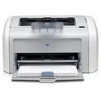 TENANT File **GUARANTEED Compatible Checks**

**Professional checks make your business stand out from the others. With our low prices, guaranteed quality and product compatibility, you can be sure you are getting an unbeatable combination. Complete the form on the back, sign and Email to order your checks, deposit slips, stamps and envelopes. You can be assured of quality, service, compatibility and fast turn-around from…….**

**W G Software, Inc.**

**P. O. Box 90218**

**Austin, TX 78709-0218**

**1-800-398-3904 Fax/Sales**

**Email to:**

**Sales@TenantFile.com**

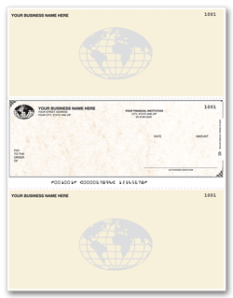

**◄ ◄ Multi-Purpose Check - 881013 Top Stub**

Size: 8 1/2” x 11” overall; 8 1/2” x 7” detached

**Colors:** (Please note: Parchment is no longer available.)

**Herringbone:** Blue, Gray, Green, Maroon, Purple, Tan, Yellow

**Premier Colors:** (**Addl** **$17 per 1000)** Tamper Guard +, Antique, Monterey, American Spirit, Blue Marble, Green Marble, Gentry

|  |  |  |  |
| --- | --- | --- | --- |
| **Description** | **500** | **1000** | **2000** |
| 1-Part | $112.00 | $152.00 | $258.00 |

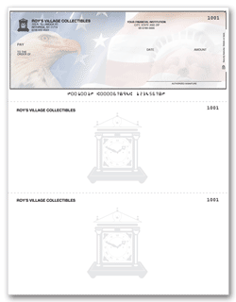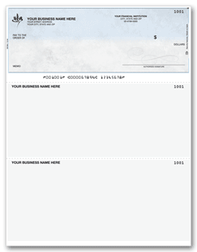**◄ ◄ Multi-Purpose Check – 881004 Bottom Stub**

**Multi-Purpose Check – 881064 Bottom Stub** ►►

Size: 8 1/2” x 11” overall; 8 1/2” x 7” detached

**Colors:** (Please note: Parchment is no longer available.)

**Herringbone:** Blue, Gray, Green, Maroon, Purple, Tan, Yellow

**Premier Colors:** (**Addl** **$17 per 1000)** Tamper Guard +, Antique, Monterey, American Spirit, Blue Marble, Green Marble, Gentry

|  |  |  |  |
| --- | --- | --- | --- |
| **Description** | 500 | 1000 | 2000  Check Style compatible with QuickBooks |
| 1-Part | $112.00 | $152.00 | $258.00 |

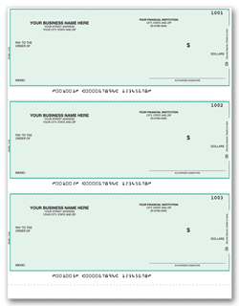

Endorsement Stamp:

Pre-Inked (Product 2023)

Black ink only **$30.50**

Name/Address Stamp:

Pre-Inked (Product 2022)

Black ink only $**29.50**

**◄ ◄Multi-Purpose Check - 880003 Check only**

**Colors:** (Please note: Parchment is no longer available.)

**Herringbone:** Blue, Gray, Green, Maroon, Purple, Tan, Yellow

**Premier Colors:** (**Addl** **$17 per 1000)** Tamper Guard +, American Spirit

|  |  |  |  |
| --- | --- | --- | --- |
| **Description** | 500 | 1000 | 2000 |
| 1-Part | 108.95 | $144.95 | $229.95 |

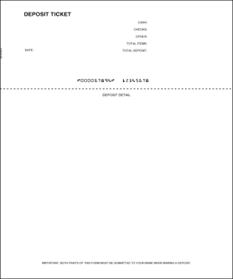 **Carbonless Deposit Ticket Booklet - #100018** ►►

|  |  |  |  |
| --- | --- | --- | --- |
| **Description** | **150** | **300** | **600** |
| 1-part | $29.95 | $42.95 | $66.95 |
| 2-part | $39.95 | $59.95 | $89.95 |

**◄◄Printable Deposit Tickets - #81019**

**NOTE: The prices shown include the base price only. Any changes to the** **product such as logos, premier colors, etc. will result in extra work charges. Additional artwork and time may be required on custom logos and trademark symbols**. **All** **print is in black. There will be an additional charge for color ink.**

**Prices are subject to change without notice.**

**Our deposit tickets meet or exceed industry standards for MICR quality and**

**are guaranteed ICR (Image Character Recognition) compatible.**

|  |  |  |
| --- | --- | --- |
| **500** | **1000** | **2000** |
| $68.00 | $110.00 | $184.00 |

**Double Window Self-Seal Envelopes #92534**

|  |  |  |
| --- | --- | --- |
| **500** | **1000** | **2000** |
| $80.00 | $116.00 | $225.00 |

**Form and Pricing available at** [**WWW.TENANTFILE.COM**](http://www.TenantFile.com) **> PRODUCTS > CHECKS AND SUPPLIES**

TENANT **File** CHECK ORDER FORM

**COMPLETE THIS FORM, SIGN AND EMAILTO** [**SALES@TENANTFILE.COM**](mailto:SALES@TENANTFILE.COM) **OR FAX 1-800-398-3904**

**WITH YOUR SAMPLE VOIDED CHECK OR MICR SHEET *****ALL CHECK ORDERS MUST BE PREPAID\*\*\*\*\***

### 

**SHIP TO: (All orders shipped UPS Ground unless you request air shipment at additional cost. – Cannot ship to Postal Boxes)**

|  |  |  |  |
| --- | --- | --- | --- |
| **Customer:** | | **Phone Number:** | |
| **Company Name:** | |  | |
| **Street Address:** | |  | |
| **City, State, Zip:** | | **Email:** | |
| **CREDIT CARD BILLING INFORMATION: Or Same as Ship To Address** | |  | |
| **Customer:** | | **Phone Number:** | |
| **Company Name:** | |  | |
| **Street Address:** | |  | |
| **City, State, Zip:** | | **Email:** | |
| **\*\*INFORMATION TO BE PRINTED – MUST BE COMPLETED\*\*** | | | |
| **IMPRINT:** | | | |
|  | | | |
|  | | | |
|  | | | |
| **ROUTING #** | | **BANK ACCT #** | |

|  |  |  |  |  |  |
| --- | --- | --- | --- | --- | --- |
| **PRODUCT NUMBER** | **DESCRIPTION** | QTY. | **COLOR** | **STARTING CK#** | **PRICE** |
|  |  |  |  |  |  |
|  |  |  |  |  |  |
|  |  |  |  |  |  |
|  |  |  |  |  |  |
| **►►► ►►►Premier** | **Color Fee** | **$17.00/** | **per 1000 Checks** |  |  |
|  |  |  | **SUBTOTAL** | **→ → →** |  |

|  |  |  |
| --- | --- | --- |
| **NOTE: $17.00 per 1000 checks additional charge for all premier colors. Prices are subject to change without notice.** | **LOGO ARTWORK (New Orders ONLY):**  **$ 40.00 for Custom per new check order**  **Email in ‘.jpg’ format to Sales@TenantFile.com** | $ |
| **\*\*\*\*\*\*\*\*\*\*\*\*\*\*\*\*\*\*\*\*\*\*\*\*\*\***  **ALL NEW ORDERS REQUIRE A VOIDED CHECK SAMPLE OR MICR CODE SHEET FROM BANK** | **SHIPPING CHARGES → → →**  **10% for UPS Ground Shipping**  **Expedited Shipping $55.00 →** | $    $ |
| **TEXAS residents are required to pay 8.25% Sales Tax** | ►► ►►TEXAS SALES TAX | $ |
| **\*\*\*TO EXPEDITE SHIPPING ON REORDERS*** INCLUDE REORDER FORM FROM YOUR ORIGINAL ORDER** | TOTAL → → → | $ |

**□ Check or money order enclosed made payable to W G Software Company, Inc. - Additional delays for orders sent by mail and placed by check.**

**□ VISA □ MC □ AMX □ DISCOVER Card No:_________________________________________________**

Χ___________________________________________ _________ _______________________________

**Authorized Signature Exp. Date: Printed Name of Cardholder**